
KENBRIGHT ACTUARIAL AND FINANCIAL SERVICES LIMITED
REINSURANCE CERTIFICATE
INTERNAL TECHNICAL PROCEDURES
G | VERSION 1.0
 |  |  | JANUARY 2026
 |  |  | KAFS POLICY

Kenbright Actuarial & Financial Services Limited
26th Floor- Prism Towers – 3rd Ngong Avenue
P. O. Box 28281 – 00200
Nairobi, Kenya
kafs@kenbright.co.ke

 |  | 

DOCUMENT TRACKING
Revision History
Version | Author | Date | Revision
1.0 | Kenbright Actuarial and Financial Services Limited | January 2026 | Creation

Prepared for:

Kenbright Actuarial & Financial Services Limited
26th Floor, Prism Towers
3rd Ngong Avenue, Upperhill
P.O Box 28281 - 00200
Nairobi, Kenya

OUR REF
\\Kenbright\Internal Technical Procedures\Reinsurance Certificate Manual.

DOCUMENT PURPOSE
This document has been produced as part of the internal technical procedures for KAFS and provides guidance on preparing a reinsurance certificate for both life and General insurance business.

DOCUMENT OWNERSHIP
The owner of this document is Kenbright Actuarial and Financial Services Limited.
TABLE OF CONTENTS
1 INTRODUCTION 5
Background 5
Key concepts. 5
2 OVERVIEW OF THE REINSURANCE CERTIFICATE 6
Proportional Treaties 6
Non- Proportional Treaties 8
Risk XoL 8
Catastrophe XoL 8
Stop Loss XoL 9
Facultative Reinsurance 9
Credit Rating of Reinsurers 10
Reinsurance brokers 11
Minimum and Deposit Premiums (MDPs) in Reinsurance 11
Importance of MDPs 12
Ceding Commission 13
3 REINSURANCE CERTIFICATE WORKING FILE 14
Intro (Introduction) 14
Frequency 14
Severity 15
RI Summary 15
Revenue Account 16
Simulator 16
Summary 17
Validation of results. 18
4 APPROVAL 20

ABBREVIATIONS
NAME | DEFINITION
KAFS | Kenbright Actuarial & Financial Services Limited
GWP | Gross Written Premium
GEP | Gross Earned Premium
NEP | Net Earned Premium
EGNPI | Estimate of the insurer’s gross net premium income
MDPs | Minimum Deposit Premiums

INTRODUCTION

Background
  - The reinsurance certificate is a formal document that summarizes the reinsurance program of an insurer. It provides evidence of the arrangements in place, listing the reinsurers, brokers, and terms agreed upon.
  - The certificate is important because:
  - It assures regulators that insurers are adequately protected against catastrophic losses.
  - It demonstrates that insurers are partnering with financially sound and approved reinsurers.
  - It enhances policyholder confidence by showing that claims can be met even in adverse circumstances
  - In Kenya, the Insurance Regulatory Authority (IRA) requires insurers to maintain transparent and compliant reinsurance programs. The certificate is one of the key tools used to demonstrate compliance.

Key concepts.
  - Reinsurance Broker- An intermediary licensed to arrange reinsurance contracts on behalf of insurers.
  - Credit Rating -An assessment by an agency (e.g., AM Best, GCR, S&P) of a reinsurer’s ability to pay claims. Higher ratings mean lower default risk.
  - Regulatory Compliance- Insurers must ensure that reinsurers meet rating and financial soundness requirements, and that brokers are duly licensed.
  - Minimum and Deposit Premiums (MDPs)- The minimum amount of premium that a cedant (the insurer) agrees to pay a reinsurer under a non-proportional reinsurance treaty, regardless of the actual premium income generated during the treaty period.

OVERVIEW OF THE REINSURANCE CERTIFICATE

  - Reinsurance treaties can generally be divided into Proportional Treaties and Non-Proportional Treaties.

Proportional Treaties
  - In proportional reinsurance, the insurer and reinsurer share premiums and claims in an agreed proportion. The reinsurer receives a portion of the premium and, in return, pays the same portion of any claims. Two common forms are:
- Surplus Treaties
  - Under surplus arrangements, the insurer decides how much of each risk to retain (usually expressed as a “line” or fixed amount).
  - Any sum insured above this retention is ceded to the reinsurer, up to an agreed limit.
  - This type of treaty is useful for classes where sums insured can vary significantly, such as fire, engineering, or marine.
  - Example: If an insurer retains one line of 30 million, and a risk of 50 million is written, the insurer keeps 30 million while the balance (20 million) is passed to reinsurers as shown below;
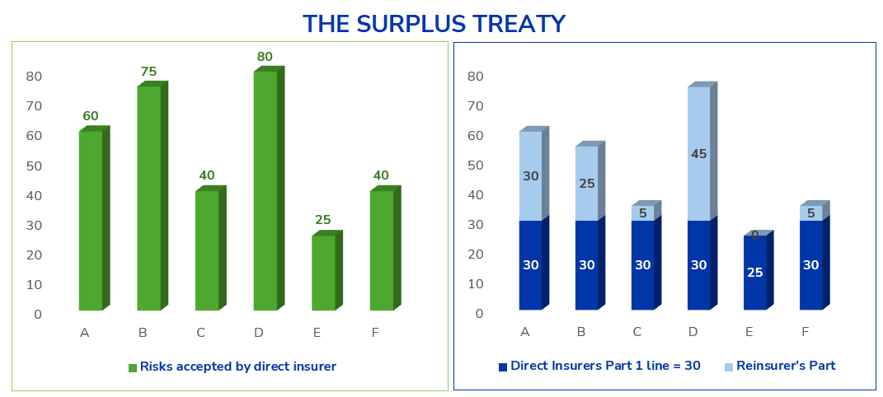
NOTE

  - The insurer always retains its chosen line but can cede large risks beyond this.

- Quota Share Treaties
  - In quota share treaties, a fixed percentage of every risk is shared between the insurer and the reinsurer.
  - Both premiums and claims are divided according to the agreed percentage.
  - This type of treaty is often used for new classes of business, high-frequency lines like motor, or for portfolios that need strong capital relief.
  - Example: If the quota share is 75%, the insurer keeps 75% of premiums and claims, while 25% goes to reinsurers as shown below.
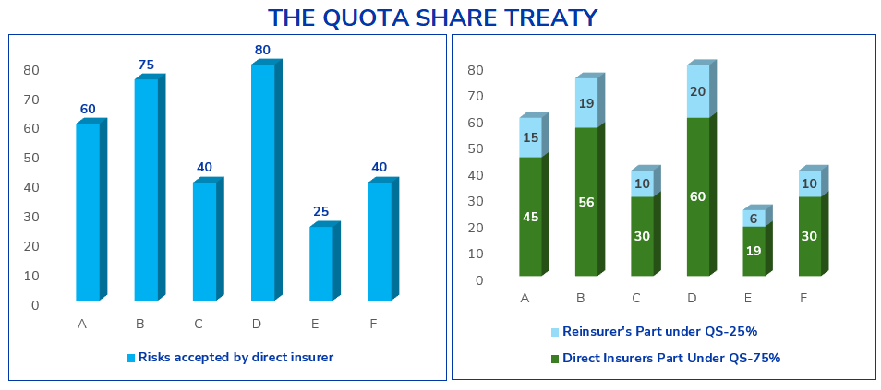
NOTE

  - The sharing is uniform across all risks, regardless of size.

Non- Proportional Treaties
  - In non-proportional reinsurance, the reinsurer only pays when losses exceed a certain threshold (the insurer’s retention). The insurer bears losses up to this level, and the reinsurer covers the excess.
  - There is no pre-decided fixed proportion in which the reinsurer and reinsured share the premiums and losses of a portfolio. Hence this is called “Non Proportional”.
  - These treaties protect against large individual losses or catastrophic events.
  - Types of non-proportional reinsurance include;
  - Risk XoL/(Individual risk XoL)
  - Catastrophe XoL
  - Stop Loss XoL/Aggregate XoL

Risk XoL
  - Protects the insurer against large losses arising from individual risks.
  - For instance, claim no 6 below is recoverable under the cover.
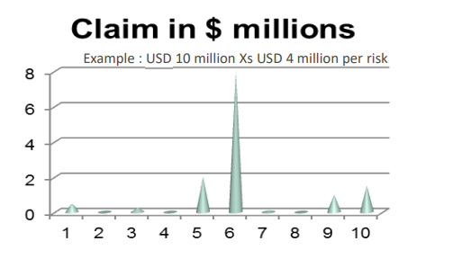

Catastrophe XoL
  - Protects against accumulation of many losses from a single event (e.g., earthquakes, floods, or hurricanes).
  - The insurer retains a set amount for the event, and the reinsurer pays losses above this retention, up to a specified limit.

Stop Loss XoL
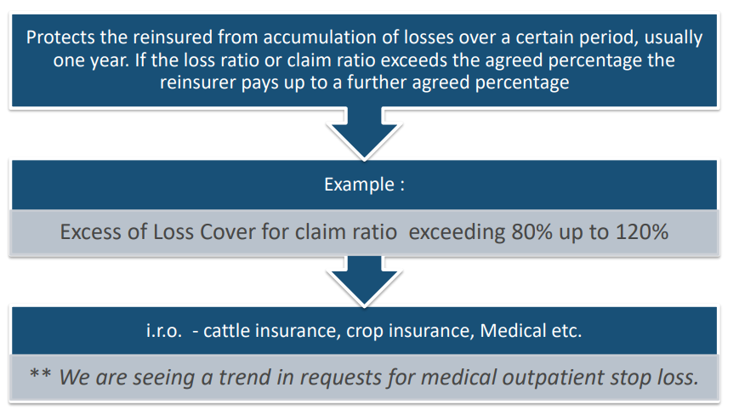

Facultative Reinsurance
  - Facultative reinsurance can be either proportional or non-proportional, depending on how the cover is designed.
  - It is treated as a separate category because it applies to individual risks, not portfolios, each risk is separately underwritten and negotiated.
  - Proportional facultative- reinsurer takes a share of premiums and claims for a single risk.
  - Non-proportional facultative- reinsurer pays claims above a defined retention for that specific risk.
  - Facultative is typically used for large, unusual, or complex risks that exceed the cedant’s treaty capacity or underwriting limits.
  - Example: A high-value industrial plant, a large marine vessel, or a unique engineering project may be placed facultatively if the sum insured exceeds the insurer’s treaty capacity or internal retention limits.

Aspect | Facultative Reinsurance | Treaty Reinsurance
Scope of Cover | Covers individual risks one at a time. | Covers an entire portfolio or class of business.
Acceptance | Reinsurer can accept or reject each risk. | Reinsurer must accept all risks that fall within the treaty terms.
Negotiation | Negotiated separately for every risk. | Negotiated once for the whole portfolio.
Use Case | For large, complex, or unusual risks outside normal underwriting guidelines. | For regular, homogeneous risks written as part of day-to-day business.
Flexibility | High flexibility, terms tailored per risk. | Less flexibility, standardized terms for the full book.
Administration | More time-consuming and administratively heavy. | Efficient and easy to administer once the treaty is in place.
Certainty of Cover | No automatic cover; depends on reinsurer’s decision for each case. | Automatic cover for all qualifying risks.
Pricing | Price varies by individual risk characteristics. | Pricing is based on the performance of the entire portfolio.
Documentation | Requires individual facultative certificates for each placement. | Governed by a single treaty agreement and periodic bordereaux.

Credit Rating of Reinsurers
  - A credit rating is an independent assessment of a reinsurer’s ability to meet its financial obligations.
  - Common rating agencies include AM Best, Standard & Poor’s (S&P), Fitch, and Global Credit Rating (GCR).
  - Credit ratings are significant as they help insurers identify and engage with financially stable reinsurers.
  - A higher rating, such as “A” or above, signals a stronger claims-paying ability and provides greater security to the cedant.
  - In addition, regulatory frameworks often restrict or discourage cessions to poorly rated or unrated reinsurers, making credit ratings not only a measure of reliability but also a compliance requirement.
NOTE

  - Think of credit ratings as a “report card” for reinsurers. Just as banks prefer lending to clients with high credit scores, insurers prefer reinsurers with strong ratings to reduce default risk.

  - The table below shows a sample of reinsurance rating shared by an insurer.
Reinsurer | Rating | Agency
Africa Reinsurance Corporation | A | AM BEST
Continental Reinsurance Limited | B+ | AM BEST
East Africa Reinsurance Company Limited | B | AM BEST
Ghana Reinsurance Company | B | AM BEST
Kenya Reinsurance Corporation | B | AM BEST
WAICA Re (Kenya) Limited | B | AM BEST
Zep-Re (PTA Reinsurance Company) | B++ | AM BEST

Reinsurance brokers
  - Reinsurance brokers act as intermediaries between the cedant (insurer) and reinsurers. They negotiate terms, source capacity, and ensure competitive placement of risks. The certificate must reflect these details to establish transparency and accountability.
  - Regulators often require disclosure of whether brokers are domestic or foreign.
  - Local brokers support domestic capacity building, comply with local laws, and may be prioritized in regulatory frameworks.
  - Foreign brokers expand access to global markets, specialist capacity, and expertise, especially for complex risks.
  - Many regulatory authorities impose minimum local participation (for example, requiring a certain percentage of business to pass through locally licensed brokers). Including incorporation details ensures compliance with such mandates
  - Disclosing incorporation details reassures stakeholders that proper due diligence has been conducted and the risk transfer is legitimate.
  - The table below is a sample of local and foreign reinsurance brokers.
Name of Reinsurance Broker | Incorporation Details (Local, Foreign)
First Re | Local
Reinsurance Solutions | Foreign
JB Boda | Foreign

Minimum and Deposit Premiums (MDPs) in Reinsurance
  - A Minimum and Deposit Premium (MDP) is the minimum amount of premium that a cedant (the insurer) agrees to pay a reinsurer under a non-proportional reinsurance treaty, regardless of the actual premium income generated during the treaty period.
  - Deposit Premium is the initial amount payable at the start of the treaty, usually based on an estimate of the insurer’s gross net premium income (EGNPI).
  - Minimum Premium represents the guaranteed premium the reinsurer will receive, even if the actual written premium is less than expected.
  - For the non – proportional treaties, an example of the Minimum Deposit Premiums to be charged are shown in the table below;
Minimum Deposit Premium (MDP) Summaries
Treaty Name | Estimated Gross Net Premium Income (EGNPI) - in KES | Rate (%) | Minimum & Deposit Premium (MDP) - in KES
Motor and Liability XOL - Layer 1 | 1,500,000,00.00 | 0.18% | 2,295,00.00
Motor and Liability XOL - Layer 2 | 1,500,000,00.00 | 0.20% | 2,550,00.00
Fire and Engineering XOL - Layer 1 | 400,000,00.00 | 2.50% | 8,500,00.00
Fire and Engineering XOL - Layer 2 | 400,000,00.00 | 0.83% | 2,822,00.00
Fire and Engineering XOL - Layer 3 | 400,000,00.00 | 0.89% | 3,026,00.00
Marine Cargo & Hull XOL - Layer 1 | 170,000,00.00 | 2.00% | 2,720,00.00
  - The MDP rates for the proposed treaties were determined as a proportion of the respective Estimated Gross Net Premium Income and Premium rate for the class of business.
NOTE

  - The MDP protects the reinsurer from receiving inadequate premiums in situations where the cedant’s business volume is lower than forecast.
  - When you see an MDP table in a reinsurance certificate, you should check whether the rates applied are consistent with the risk layers, confirm that the EGNPI is realistic, and ensure the cedant is not underpaying the reinsurer. This protects both the insurer and reinsurer and guarantees the treaty’s fairness and sustainability.

Importance of MDPs
  - Reinsurers commit significant capital to cover catastrophic or large claims under non-proportional treaties. MDPs ensure they receive a minimum level of compensation even if the insurer’s premium income is lower than expected.
  - Since deposit premiums are payable upfront (or in instalments), reinsurers benefit from predictable cash inflows, which improves their solvency planning and capital management.
  - By linking premiums to EGNPI, reinsurers ensure that the cedant contributes fairly to the reinsurance pool based on projected business volume.
  - Different layers (e.g., Motor Layer 1 vs. Layer 3) attract different MDP rates. Higher layers usually carry lower rates since they are less likely to be triggered, while lower layers have higher rates due to higher frequency of claims.
  - Regulators often require insurers to disclose MDPs in reinsurance certificates as part of assessing whether the reinsurance program is adequate, sustainable, and fair to all parties.
  - Without MDPs, cedants could understate their expected premium income to reduce reinsurance costs. MDPs prevent this by establishing a floor below which premiums cannot fall.

Ceding Commission
  - Ceding commission refers to the percentage allowance that the reinsurer pays back to the cedant to cover acquisition expenses, administrative costs, and to support the overall viability of the ceded business.
  - It is a key commercial term in any reinsurance treaty, as it determines how costs and profits are shared between the cedant and the reinsurer.
  - Ceding commission is included in the reinsurance certificate to provide transparency on the financial terms of the treaty and ensure a clear understanding of how expenses and profits will be shared.
  - It is important to interpret commission levels correctly, stable commissions generally signal consistent portfolio performance, whereas changes whether increases or decreases, often reflect reinsurer feedback on profitability, risk quality, or market shifts.
  - The table below shows an example of proposed reinsurance treaties
Ceding Commission (in %)
Line of Business (Treaty) | 2025 | 2026
Fire & Engineering Surplus - Fire | 35% | 35%
Fire & Engineering Surplus - Engineering | 28% | 28%
Marine Surplus | 27.0% | 28.5%
Bonds Quota Share | 25% | 25%
PVT Quota Share & Surplus | 20% | 20%
Miscellaneous Accident Surplus | 30% | 30%
  - Compared to 2025, the ceding commissions remain the same except for Marine Surplus treaty.

REINSURANCE CERTIFICATE WORKING FILE

  - The figure below shows a preview of the working file for reinsurance certificate computation.
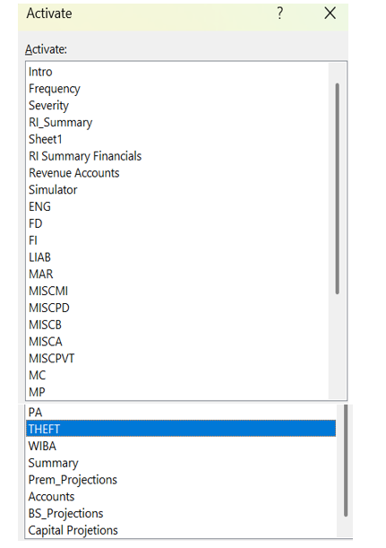

Step by step guide to filling and updating the working file

Intro (Introduction)
  - Enter company name, valuation date and the project name (Reinsurance certification).

Frequency
  - This tab computes the frequency as at the valuation date.
  - Paste your unique exposures in the exposure table.
  - Paste the count of unique claims in the claims incurred table.
  - Frequency is computed as below:
$$Frequency= \frac{Count of Unique Claims}{Exposure (Unique)}$$

Severity
  - This tab computes the severity as at the valuation date.
  - Paste the claims reported amounts in the incurred table.
  - Severity is computed as below:
$$Severity= \frac{Total Gross Amount}{Count of Unique Claims}$$
NOTE
  - We use loaded claims reported amounts in the working file.
  - IBNER loading is an actuarial adjustment that loads up claim amounts for reporting delays and late development. So if you had 10,000 as reported claims amounts and apply 20% IBNER, you assume 12,000 “true” ultimate claims amounts.

RI Summary
  - This summary is computed from our data in comparison with the numbers in the revenue account.
  - Using our data Paste the reported claims table showing the gross claims amounts, reinsurance recoveries and net claims.
  - Using our data Paste the premium cession table showing the gross premium, treaty premium and Net premium.
  - Then compute experience ratios (Cession and Recovery).
$$Premium Cession Rate= \frac{Premium Ceded }{Gross Premium}$$
$$Premium Ceded= Gross Premium-Net Premium$$
$$Claim Recovery Rate= \frac{Reinsurance Recoveries }{Gross Claims}$$
$$Claim Recoveries= Gross claims*Ceded percentage$$
  - Xlookup the gross and net figures from the financials as well and compute the premium cession rates and claim recovery rates.
  - Notably, on this tab update with the insurer’s current treaty retentions as illustrated in the table below.
Beetroot Insurance Company
Summary of Reinsurance Arrangements Reinsurance Treaties
Form & Type of Reinsurance |  | Class of Insurance | Retention |  |  |  | Reinsurers
 |  |  | 2025 |  | 2026 |  | 2025 |  | 2026
 |  |  | %/Lines | Limit | %/Lines | Limit | %/Lines | Limit | %/Lines | Limit
Proportional Business | Surplus | Fire | 1 | 50 | 1 | 50 | 15 | 750 | 17 | 850
 |  | Engineering | 1 | 50 | 1 | 50 | 15 | 750 | 15 | 750
 |  | Marine Cargo, GIT & Hull
 |  | Cargo & GIT | 1 | 5 | 1 | 5 | 18 | 90 | 18 | 90
 |  | Hull & PLL | 1 | 2 | 1 | 2 | 18 | 36 | 18 | 36
 |  | Miscellaneous
 |  | Accident | 1 | 10 | 1 | 10 | 15 | 150 | 10 | 150
 |  | Golfer | 1 | 10 | 1 | 10 | 15 | 150 | 15 | 150
 |  | Theft | 1 | 10 | 1 | 10 | 15 | 150 | 15 | 150
 | Quota Share | Bonds
 |  | Per Bond | 30% | 30 | 30% | 30 | 70% | 100 | 70% | 100
 |  |  | 30% | 70 | 30% | 70 | 70% | 300 | 70% | 300
 |  | PVT | 30% | 60 | 30% | 60 | 70% | 140 | 70% | 140
 |  | Agriculture | 20% | 4 | 20% | 4 | 80% | 16 | 80% | 16
Non-Proportional Business | Excess of Loss | Fire and Engineering
 |  | Workmen's Compensation |  | 15 |  | 15 | 2layers | 250 | 2layers | 250
 |  | PVT |  | 5 |  | 5 | 3layers | 345 | 3layers | 345
 |  | Motor |  | 3 |  | 3 | 3 layers | 295 | 3layers | 295
 |  | Non - Motor
 |  | Micro Insurance |  |  |  |  |  |  | N/A
 |  | Motor, Accident, Liability |  | 5 |  | 5 | 3 layers | 345 | 3layers | 345

Revenue Account
  - The revenue account records the insurance income and outgo for each class of business.
  - Insert the current revenue account as at the valuation date.

Simulator
  - This shows the reinsurance simulation parameters.
  - The model assumes claim sizes follow a Gamma and Log Normal distribution.
  - Input parameters- Set the business class, then the rest of the details i.e distribution, number of expected claims, retention rate and proportional RI limit will automatically pick.
  - Run the simulation- The workbook will generate claim amounts (gross, net and claim recoveries).
  - You do this per class, as the simulations generate on a class wise basis.
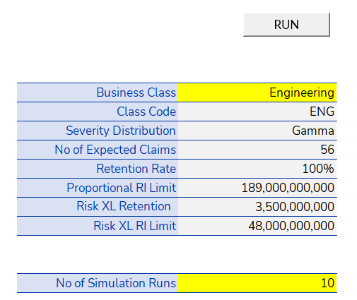
  - Observe outputs- The gross claims, net claims and reinsurer recoveries.
NOTE

This tab is a Monte Carlo–style test bench for reinsurance design. It lets you see how different treaties affect net claims if a given number of losses occur, based on chosen severity distributions.
Premium projections- Provides a basis for comparison against your results. Majorly on Net loss ratios.

Summary
  - This tab has a summary of the generated gross claims, Net claims and Claim recoveries for all classes. Also, it shows the project loss ratios and proportion of claims to the company assets as shown in the tables below.
  - Update the formulas to correctly pick the correct figures from their respective class tabs.
Class | Beetroot: Expected Total Claims Experience
 | Gross Claims | Prop RI Recoveries | Non-Prop RI Recoveries | 95th Net Claims
Engineering | 3,420,079,259 | - | - | 3,420,079,259
Fire Domestic | 506,407,654 | - | - | 506,407,654
Fire Industrial | 11,411,079,380 | - | - | 11,411,079,380
Liability | 3,967,733,298 | - | - | 3,967,733,298
Marine | 5,378,268,222 | - | - | 5,378,268,222
Miscellaneous | 56,016,306 | - | - | 56,016,306
Motor Commercial | 5,210,849,682 | - | - | 5,210,849,682
Motor Private | 664,930,457 | - | - | 664,930,457
Personal Accident | 89,543,966 | - | - | 89,543,966
Theft | 3,389,339 | - | - | 3,389,339
Workmen's Compensation | 656,242,234 | - | - | 656,242,234
Grand Total | 31,364,539,796 | - | - | 31,364,539,796
  - The net expected claims experience is compared to the company’s assets as at the analysis date as shown in the table below:
Beetroot General Insurance Company
Proportion of Projected Net Claims to:
Class | Projected  Net Assets | Projected  Available Capital | Projected  Liquid Assets
Engineering | 1% | 1% | 1%
Fire Domestic | 0% | 0% | 0%
Fire Industrial | 3% | 3% | 3%
Liability | 1% | 1% | 1%
Marine | 1% | 1% | 1%
Miscellaneous | 0% | 0% | 0%
Motor Commercial | 1% | 1% | 1%
Motor Private | 0% | 0% | 0%
Personal Accident | 0% | 0% | 0%
Theft | 0% | 0% | 0%
Workmen's Compensation | 0% | 0% | 0%
Overall | 8% | 8% | 8%
  - On an overall basis, the 2026 projected net claims represented 8% of the company’s net assets, 8% of the available capital, and 8% of the liquid assets as of 30 June 2025.
  - It is worth noting that the net expected claims exceed the company’s Total Capital Available and represent a small proportion of the company’s Net Assets and Liquid Assets as at the Analysis Date.
  - We also assess the projected claims experience against the company’s expected revenue performance for the year 2026 and have estimated the expected Net Loss Ratio to be 9%.
Projected Loss Ratio
Amounts in KES Millions
Net Earned Premiums* | 335,091
Net Incurred Claims | 31,365
Net Expected Claim Ratio | 9%
95th Percentile Net Incurred Claims | 31,714
95th Percentile Net Claim Ratio | 9%
*NEP for treaty business estimated based on insurer's Business Plan for the year 2026 and recent experience
  - As per the projected net claim experience for the company at a 9% confidence level, the Net Loss Ratio is expected to be less than 9%.

Validation of results.
  - Judgement checkpoints for your results are;
  - The projected loss ratio is consistent with the prior year loss ratio. The movement needs to be supported by business assumptions such as better underwriting practices and pricing, premium growth, or enhanced reinsurance protection.
  - For instance, in our case, the projected claims are quite low from our model as compared to the projected claims in the Financials. Hence, we need to adjust our projected claims by adjusting the credibility weights in the frequency tab.
  - This will help increase the projected claims, hence increase the loss ratio.
  - Net Earned Premiums and Net Incurred Claims are traceable to the insurer’s business plan and prior experience. Year-on-year shifts should be explained, ensuring that assumptions are realistic and in line with portfolio performance.
  - The frequency and severity results should be consistent with numbers in the FCR report.
  - Notably, compare the projected claims with prior year results and the movement should be realistic and consistent as shown below.
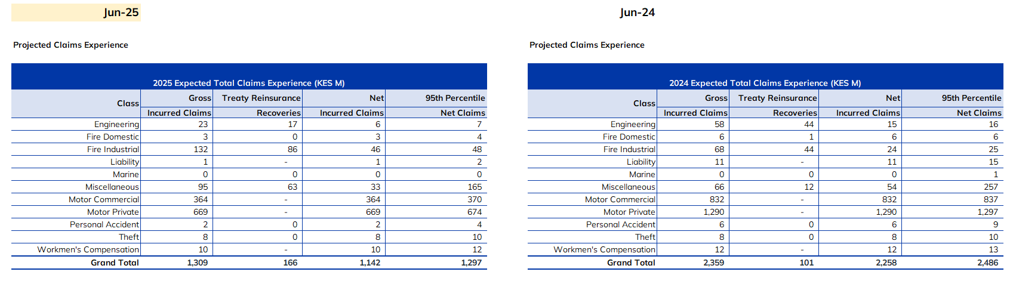

APPROVAL
Thus, adopted and signed by the management and Chief Actuary of KAFS in January 2026.
APPROVED BY
Ezekiel Macharia
Chief Actuary & Managing Director – Kenbright Actuarial and Financial Services Limited

Date: January 2026
Signed:



About Us

Kenbright Actuarial & Financial Services Limited (KAFS)
Prism Towers, 26th Floor
3rd Ngong Avenue, Nairobi
Kenya
www.kenbright.co.ke

Customer Service Lines: +254 (020) 22 111 52

Document Version

January 2026

Version 1.0: Creation

Reproduction – in total or in part – only with the permission of KAFS.

Key Contacts

E Macharia, FIA C.Act, FeASK
Chief Actuary & Managing Director
E-mail: ezekiel@kenbright.africa
Phone: +254 722 540 045

